**XII ABSTRACT**

Light-emitting diodes (LEDs) have many application categories as display backlighting, communications, medical services, signage, and general illumination. In order to minimize the cost and time consumption, a numerical simulation of three–dimensional (3D) LEDs devices will construct to examine the characteristic. This project provides the groundwork for an understanding of the reliability issues of LEDs numerical simulation procedure.

A 3D numerical simulation of LED including electronic, thermal and optical characteristic will present. The electronic characteristic is based on the semiconductor equations system. The semiconductor part is described by the Drift-Diffusion and Poisson equations that can explain the internal device physics with a 3D numerical model, such as hole and electron current density distribution, current crowding, carrier leakage, self- heating, etc. After solving Drift-Diffusion model for the carrier transport to receive the radiative and non-radiative recombination, electronic transport in a LED. With the material parameters are identified and their affecting on the simulation results is investigated. With the understanding of the radiative and non-radiative recombination, they use to calculate the internal quantum efficiency and heat source also discussed in this work. In addition, this project also analyzes the size of n-electrode affect the current density distribution not only in the active layer but also the whole entire devices by the hole and electron current density distribution. The External Quantum Efficiency (EQE) is measured using electroluminescence measurements. Finally the optimization of LEDs structure to increase Internal Quantum Efficiency (IQE) and reduce droop efficiency is the main focus of this project.

Keyword: LEDs, Drift and Diffusion, numerical, Poisson, electrical, thermal, optical

**XIII . research from the prior year（either Chinese or English is acceptable）:**

*Summary of results : Summarize the project contents and main research results of the past five years (for continued projects, attach the progress report of the research from the prior year).*

**XIII . Contents of Grant Proposal（either Chinese or English is acceptable）:**

*Research project’s background and goals: Describe in detail the background, goals, significance, status of domestic or foreign research related to this project, and bibliography of major reference materials, etc. If this is a sub-project of an integrated project, state overall relevance with other sub-projects for each point listed above.*

**Research human cost**

**1st year**

(A) full-time assistant, lecturer and assistant adjunct assistant level, temporary wage

|  |  |  |  |  |  |  |  |
| --- | --- | --- | --- | --- | --- | --- | --- |
| Category / Level | Number of people | Name | Operand-months (including labor and health insurance costs) | Subtotal | Amount | Sources of funding  The grant funding will demand  Provided with the funds of the agency name and amount | |
| **Total** |  |  |  |  |  |  |  |

(B) the doctoral graduate, postgraduate courses and college students part-time assistant

|  |  |  |  |  |  |
| --- | --- | --- | --- | --- | --- |
| Level / Name | Number of people(1) | Number of units per person per month(2) | Months aid prize (3) | Subtotal(4)=2000$x(1)x(2)x(3) | The specific nature of the work as covered in this research project, and the scope of the project |
| Master Graduate Research Grants | 2 |  |  |  | Responsible for research data collection, assisted experiments |
| Doctorate fellowships | 1 |  |  |  | Responsible for planning the experiment, the establishment of the theoretical model and simulation models, and with the results to be analyzed |
| **Total** | | | |  | |

**2nd year**

(A) full-time assistant, lecturer and assistant adjunct assistant level, temporary wage

|  |  |  |  |  |  |  |  |
| --- | --- | --- | --- | --- | --- | --- | --- |
| Category / Level | Number of people | Name | Operand-months (including labor and health insurance costs) | Subtotal | Amount | Sources of funding  The grant funding will demand  Provided with the funds of the agency name and amount | |
| **Total** |  |  |  |  |  |  |  |

(B) the doctoral graduate, postgraduate courses and college students part-time assistant

|  |  |  |  |  |  |
| --- | --- | --- | --- | --- | --- |
| Level / Name | Number of people(1) | Number of units per person per month(2) | Months aid prize (3) | Subtotal(4)=2000$x(1)x(2)x(3) | The specific nature of the work as covered in this research project, and the scope of the project |
| Master Graduate Research Grants | 2 |  |  |  | Responsible for research data collection, assisted experiments |
| Doctorate fellowships | 1 |  |  |  | Responsible for planning the experiment, the establishment of the theoretical model and simulation models, and with the results to be analyzed |
| **Total** | | | |  | |

**3rd year**

(A) full-time assistant, lecturer and assistant adjunct assistant level, temporary wage

|  |  |  |  |  |  |  |  |
| --- | --- | --- | --- | --- | --- | --- | --- |
| Category / Level | Number of people | Name | Operand-months (including labor and health insurance costs) | Subtotal | Amount | Sources of funding  The grant funding will demand  Provided with the funds of the agency name and amount | |
| **Total** |  |  |  |  |  |  |  |

(B) the doctoral graduate, postgraduate courses and college students part-time assistant

|  |  |  |  |  |  |
| --- | --- | --- | --- | --- | --- |
| Level / Name | Number of people(1) | Number of units per person per month(2) | Months aid prize (3) | Subtotal(4)=2000$x(1)x(2)x(3) | The specific nature of the work as covered in this research project, and the scope of the project |
| Master Graduate Research Grants | 2 |  |  |  | Responsible for research data collection, assisted experiments |
| Doctorate fellowships | 1 |  |  |  | Responsible for planning the experiment, the establishment of the theoretical model and simulation models, and with the results to be analyzed |
| **Total** | | | |  | |

**Research equipment cost**

**1st year**

|  |  |  |  |  |  |  |  |
| --- | --- | --- | --- | --- | --- | --- | --- |
| Category | The device name (Chinese / English) | Description | The number of | Unit price(TWD) | Amount | Sources of funding | |
| The grant funding will demand | Provided with the funds of the agency name and amount |
| Instruments and Equipment Information | Computer server | Because planned to perform multiple physical computing, so need higher-order computer server | 1 | 130.000 | 130.000 | 130.000 |  |
| Instruments and Equipment Information | COMSOL software maintenance and update | COMSOL software use plan, the plan moderator purchased, but need to be maintained and updated annually, to enhance its capabilities to strengthen the effectiveness of the implementation plan. | 1 | 150.000 | 150.000 | 150.000 |  |
| Instruments and Equipment Information | Thermal resistance measurement equipment | Because LEDs chips high voltage and low current characteristics, the traditional method of measuring the amount of forward bias mode of LED junction temperature will not apply. This plan will purchase a low correlation between the amount of current measurement device with high resolution signal acquisition device, the research team with this original temperature measurement equipment, set up their own LEDs is suitable for the thermal resistance measurement equipment. | 1 | 400.000 | 400.000 | 400.000 |  |
| **Total** | | | |  |  |  |  |

**2nd year**

|  |  |  |  |  |  |  |  |
| --- | --- | --- | --- | --- | --- | --- | --- |
| Category | The device name (Chinese / English) | Description | The number of | Unit price(TWD) | Amount | Sources of funding | |
| The grant funding will demand | Provided with the funds of the agency name and amount |
| Instruments and Equipment Information | Computer server | Because the couple plans to calculate the steady three-dimensional quantities with highly nonlinear and huge computation, required to purchase a higher-order computer servers, and planning for parallel processing computing server. | 1 | 130.000 | 130.000 | 130.000 |  |
| Instruments and Equipment Information | COMSOL software maintenance and update | COMSOL software use plan, the plan moderator purchased, but need to be maintained and updated annually, to enhance its capabilities to strengthen the effectiveness of the implementation plan. | 1 | 150.000 | 150.000 | 150.000 |  |
| Instruments and Equipment Information | Thermal resistance measurement equipment | Planned to establish numerical simulation model of fluorescent powder to complete analog LED chips after the light into the light of fluorescent powder to absorb and re-radiate the case. And the establishment of phosphor PL measurement laboratory equipment to verify the relevant simulation results, and provide the parameters and results analysis. | 1 | 400.000 | 400.000 | 400.000 |  |
| **Total** | | |  |  |  |  |  |

**3rd year**

|  |  |  |  |  |  |  |
| --- | --- | --- | --- | --- | --- | --- |
| Category | The device name (Chinese / English) | Description | The number of | Unit price(TWD) | Amount | Sources of funding |
| The grant funding will demand | Provided with the funds of the agency name and amount |
| Instruments and Equipment Information | Computer server | The third year will greatly increase the amount of calculation, a further purchase the high-order computer servers in a parallel processing approach to computing. | 1 | 130.000 | 130.000 | 130.000 |  |
| Instruments and Equipment Information | COMSOL software maintenance and update | COMSOL software use plan, the plan moderator purchased, but need to be maintained and updated annually, to enhance its capabilities to strengthen the effectiveness of the implementation plan. | 1 | 150.000 | 150.000 | 150.000 |  |
| **Total** | | | |  |  |  |  |

# I INTRODUCTION

The invention of blue light-emitting diode (LED) is a new energy-efficient and environment-friendly light source. White light can be created in a new way with long-lasting and more efficient alternatives to older light sources.

When Isamu Akasaki, Hiroshi Amano and Shuji Nakamura produced bright blue light beams from their semi-conductors in the early 1990s, they triggered a fundamental transformation of lighting technology. Despite considerable efforts, both in the scientific community and in industry, the blue LED had remained a challenge for three decades. White LED lamps emit a bright white light, are long-lasting and energy-efficient. They are constantly improved, getting more efficient with higher luminous flux (measured in lumen) per unit electrical input power (measured in watt). As about one fourth of world electricity consumption is used for lighting purposes, the LEDs contribute to saving the Earth's resources. Materials consumption is also diminished as LEDs last up to 100,000 hours, compared to 1,000 for incandescent bulbs and 10,000 hours for fluorescent lights. The LED lamp holds great promise for increasing the quality of life for over 1.5 billion people around the world who lack access to electricity grids: due to low power requirements it can be powered by cheap local solar power. The invention of the efficient blue LED is just twenty years old, but it has already contributed to create white light in an entirely new manner to the benefit of us all.

In this project, a macroscopic physical model for the current transport and electrical characteristics of semiconductor structures is constructed. The model is based on Maxwell’s equations, semiconductor transport equations, Fermi-Dirac statistics and basic recombination models. A corresponding model is also presented in this proposal, with a good description also about the numerical implementation of the model.

The semiconductor current equations are solved with COMSOL Multiphysics, which is a numerically powerful software for solving partial differential equations using the Finite element method (FEM). The structures modeled in this proposal are 3-dimensional projections of some commercial chips with different recently introduced highly-efficient LED structures based on group III nitride material compositions. One of them is already commercially available by CREE and the other is a recently proposed alternative. The aim of this project is to construct an advance numerical model with macroscopic based on semiconductor equation systems. This project aim is to compare these structures with each other and to see the physical phenomena deep inside the device. The results are also compared with the values found in the literature to check the accuracy of the used models and material parameters. The aim of this proposal is to describe different ideas that our lab is investigating to construct 3D numerical devices with electrical, thermal and optical characteristic. The improving LED structures with high efficiency and restrictive the efficiency droop is another aim of this proposal. We focus on the decreasing of the current overflow effect, increasing hole injection and transport efficiencies. Finally we hope that we can design our chip with high efficiency and reduce droop effect.

The structure of this proposal is the following. Literature is first reviewed to look back into the history about numerical device. Basic semiconductor physics is second reviewed with emphasis on carrier dynamics, carrier recombination and dissipation effects. In the next step, common structures and properties of semiconductor light emitting diodes technologies are presented. Finally, some experiment equipment and progress in implementation that we hope to achieve in this project.

**I. Overview of Numerical Model**

The numerical simulation has been widely used to study and investigate phenomena inside devices. Thereby, we can test with the numerical model before construct a real device. Numerical simulation is fast and low cost to check many effects with flexible various parameters and provide the physical information. However, the numerical method need exactly value of parameter and handle with the complex from the modeling physic to give accurate result.

In 1970, W. B. Joyce and S. H. Wemple [1] use basic equation is known as the Poisson-Boltzmann equation in transport problems of semiconductor. They anticipate that the collection of exact and approximate solutions and methods of obtaining analytic solutions will prove useful. A simple diode as shown in Fig.1 was analyzed in this work. The fundamentals presented of this paper give a basic premise for the later numerical model.

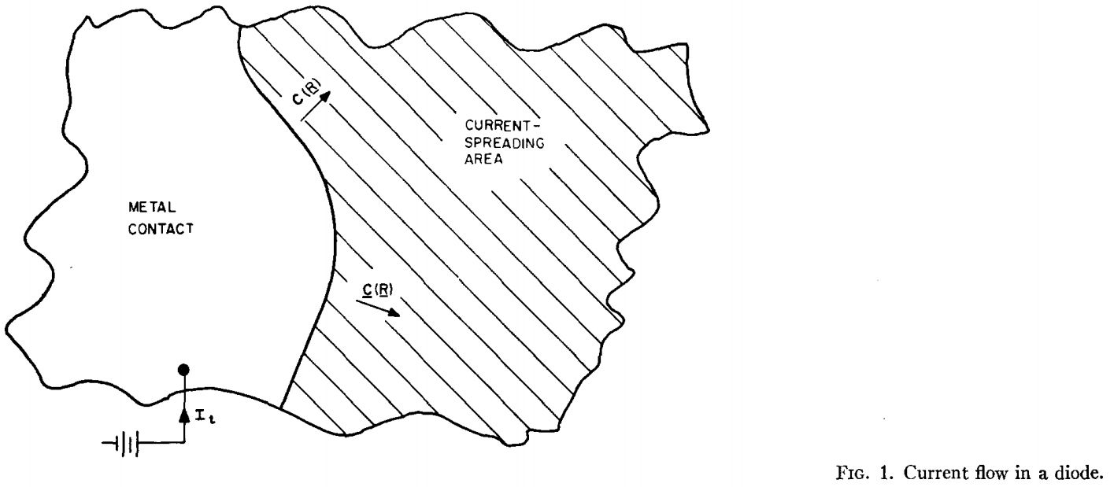

Fig.1. Current flow in a diode

In 2002, Hyunsoo Kim and et al [2] presented an advanced model to explain the current spreading phenomenon of a conventional GaN-based light-emitting diode. For this work, an equivalent circuit, consisting of the two lateral resistance components of the p-transparent electrode and the n-type layer is proposed.

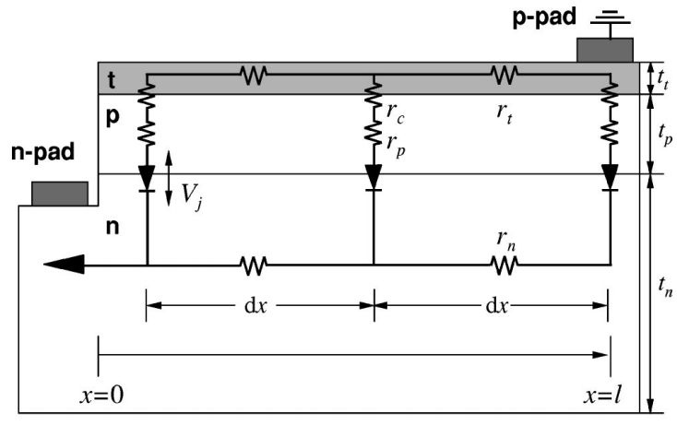

Fig.2. Equivalent LED circuit with a p pad as a physical ground

In 2004, Joachim Piprek and et al [3] was investigated and analyzed the internal device physics of 340 nm AlGaN/GaN LEDs by advanced three-dimensional simulation. The simulation incorporated a 3D drift-diffusion model for the carrier transport, the quantum well (QW) energy band-structure including interface polarization charges, the local QW spontaneous emission spectrum, as well as 3D ray-tracing for photon extraction. However, this model is not really the 3D because of the geometry shown on Fig.2. The phenomenon can directly flow through device from one contact to another contact without any spreading effect.

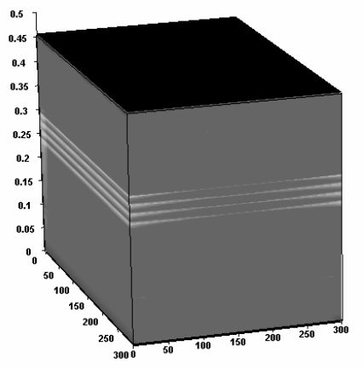

Fig.3. 3D plot of the LED showing the quantum well recombination rate (the front is equivalent to the right border in Fig. 1)

In 2007, Hyunsoo Kim et al [4] design of high-efficiency GaN-based light emitting diodes LEDs with vertical-injection geometry based on Shockley equation given as



From the numerical model, the exact understanding of the design rule provides the possibility for the fabrication of high-efficiency vertical. Each layer has their own resistivity and the device resistivity is the serial result of all layers. The advantages of resistivity method are simple and excellent agreement with experiment. However, we cannot study deep inside the physic of the device from the macro-scope with the global view.

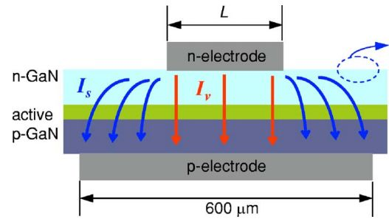

Fig.4. Schematic cross-sectional view of a fabricated LED

In 2008, Sungmin Hwang and Jongin Shim [5] developed a 3-D electrical circuit model consisting of resistances and intrinsic diodes to analyze the current spreading effect in an InGaN/GaN multiple-quantum-well light-emitting diode. They used numerical model and verified with experiment to confirm some phenomenon about electrode pattern, light intensity distribution, saturation of light power, and device reliability.

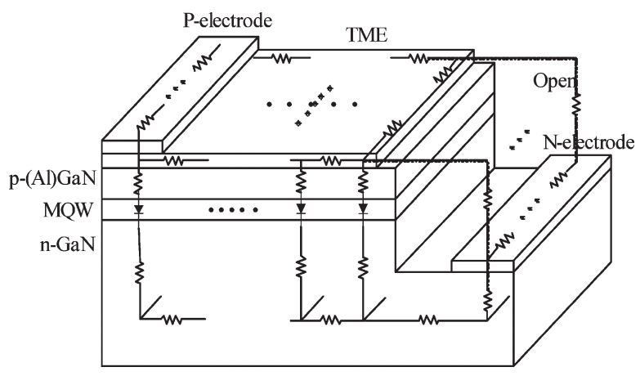

Fig.5. Schematic view of an InGaN/GaN LED structure

In 2010, Farn-Shiun Hwu and et at [6] used equivalent resistance method to analyze a 600x600 µm vertical-injection LED chip. They also investigated the effect of size of n-electrode and thermal on the current crowding.

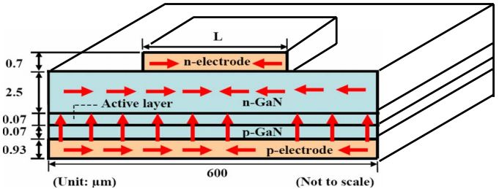

Fig.6. A cross-sectional schematic representation of a vertical LED chip in the lateral direction

In 2012, Chi-Kang Li and Yuh-Renn Wu[7] use a fully 2-D model that solves drift–diffusion and Poisson equations to investigate current flow paths and radiative recombination regions. They use numerical simulation to explore current spreading effect, wall-plug efficiency (WPE), and find out the optimization for different applications.

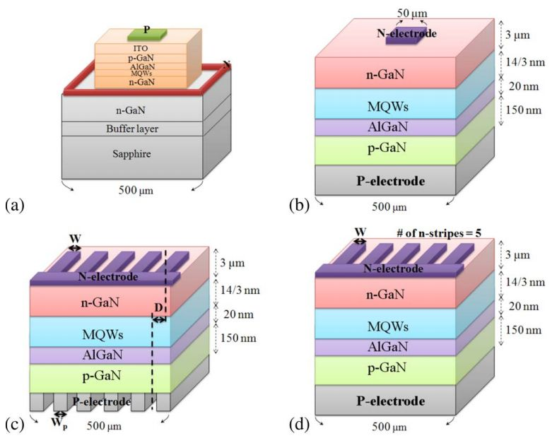

Fig.7. The schematic of LEDs models

Many different studies use resistivity method to construct LEDs model because of the simple and well agreement with measured device characteristics. However, the resistivity method cannot give a local view deep inside the physical phenomenon of LEDs. Technology LEDs manufacturing is more and more accurate so we must have an advantage numerical model to optimize the LEDs. Some studies already used semiconductor equation model system to simulate the LEDs. However, they use dedicated software or their own code to simulate LEDs devices.

**II. Overview of Efficiency droop**

In order to emit light, LEDs require an injected electrical energy into the structure. The general tendency is the higher the injected current is, the brighter the emitted light is. However, for GaN-based LEDs, a part from a certain current density (approximately 10 A/cm2), this tendency reduce with increasing injection current, which has been known as “efficiency droop”. This phenomenon is still not well understood.

The fundamental cause of the efficiency droop is a topic of active research. Many different causing to droop have been investigated: current overflow [8], poor carrier injection efficiency [9][10][11], polarization fields [12][13], Auger recombination [14], junction heating [15], carrier delocalization from quantum dots [16], exciton dissociation [17], high plasma carrier temperature [18] and quantum-confined Stark effect [19]. In the middle of these non-radiative recombination, Auger effects, current overflow (current spillover), and polarization effects represent the main mechanisms that contribute to efficiency droop. Various experiments have been set up to observe the impact of one effect over the others. To illustrate this controversy [20], researchers from Philips Lumileds are among those that believe Auger recombination is the source of the efficiency droop effect [21], while others from Virginia Commonwealth University criticize this idea and argue the difference in effective mass between electrons and holes is mainly responsible for the efficiency fall-off [22].

In a different view [13], Rensselaer Polytechnic Institute’s researchers are convinced that the polarization effect in the Quantum Well (QW) enhances the leakage of injected electrons into the p-type layer, which, according to them, is the primary mechanism that leads to an efficiency droop.

1. **Auger Recombination**

Auger recombination is a non-radiative mechanism in which the electron-hole recombination is scattered by the excitation of a free electron high into the conduction band, or by a hole deeply excited into the valence band. The highly excited carriers will finally lose energy by multiple phonon emission until they are close to band edge. More injected current in an LED leads to a rising carrier concentration in the active layer, so that Auger recombination will become an important loss causing at some case due to its dependence to the third power of the carrier density. An Auger recombination is actually divided in two mechanisms: direct and indirect. The following figure illustrates the difference between direct and indirect Auger recombination.

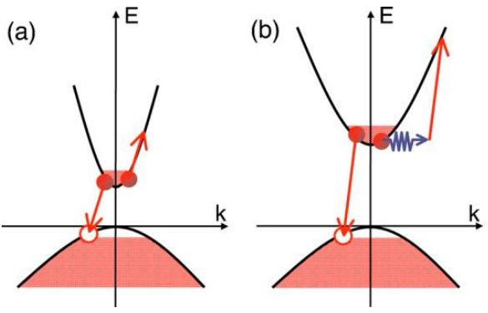

Figure 8: Illustration of (a) direct and (b) indirect Auger recombination [24]

In 2009, U.Ozgur and et al expressed the auger recombination rate as [23]

 (1)

where Cn represents the Auger recombination coefficient for electrons, n0 the equilibrium and  the excess carrier concentrations. At high injected current, the Auger recombination rate can be expressed by the following equation:

For >> n0 :  (2)

So it is dependent on the third power of the carrier concentration, this can lead to a possible main source for the efficiency droop because the multiple quantum well structures that mostly use confine the carriers in a small volume which results in higher carrier densities compared to conventional double hetero-structure active regions. However, Auger recombination is greater for relatively small band-gap materials compared to large band-gap semiconductors such as GaN.

In 2010, E. Kioupakis and et al show that the scattering mechanism that assists indirect Auger recombination (IAR) is the electron–phonon interaction, which is particularly strong in the nitrides [25]. Another scattering channel is introduced in the active region, made of InGaN layers, by the alloy-induced symmetry reduction. Charged defects may also scatter carriers and cause Auger recombination.

In 2011, E. Kioupakis and et al prove that the IAR is mediated by a scattering mechanism, which provides additional momentum and enables Auger transitions to connect to a broader range of final states. This process is important in nitrides and can account for at least some of the efficiency droop effects in nitride LEDs [24]. Phonon- and alloy assisted Auger processes are strong and cumulatively account for a sizeable Auger coefficient [24]. Thus, the indirect Auger recombination is currently one of the first candidates as a contributor to efficiency droop due to theoretical and experimental results [24] that show a high value for the indirect Auger recombination coefficient.

1. **Current Overflow**

Current overflow is a carrier loss mechanism in which electrons recombine outside the active region either radiatively (in which case the recombination occurs at an undesired wavelength) or non-radiatively, or collected by the metallic contact. The reason is that electrons have an effective mass seven times lighter than holes in GaN-related materials, which allows them to propagate faster in the crystal. Therefore, when a current is applied to the LED structure, the injected electrons reach the opposite extremity of the active region while a smaller quantity of injected holes have the time to penetrate into the active region, resulting in an significant number of electrons in the conduction band that can’t recombine. Therefore, these electrons propagate further and penetrate in the p-type layer or even collected in the metallic contact, referred to an overflow (or spillover) effect.

One important field of research is to find a way to increase the mobility of holes in the p-type layer and active region in order to enhance the electron-hole radiative recombination. One example of structure modification comes from workers at

Virginia Commonwealth University who have proposed [25] to reduce the thickness of the barrier in an InGaN multiple quantum well structure, from 12 nm to 3 nm, allowing better hole penetration. They claimed to have increased the current density of the peak external quantum efficiency from 200 A/cm2 to 1100 A/cm2. Another idea under investigation in our group is to optimize the electron blocking layer (refer to section 3.9.3) between the active region and the p-type layer that acts as a barrier to electron propagation. Therefore, much more electrons are retained in the active region, thus enhancing radiative recombination. Recently, a graded electron-blocking layer (GEBL) has been introduced [26] to overcome some issues due to a single layer EBL.3. **Polarization effects.**

Polarization effects are composed of two components, piezoelectricity and spontaneous polarization. Piezoelectricity is produced by mechanical train in the crystal, the polarization being proportional to the strain and changing sign with it. This is also known as the direct piezoelectric effect; the converse effect is when a crystal is strained when an electric field is applied. In the case of GaN-based LEDs, the direct effect induces a built-in potential because of the strain between different materials due to lattice parameter differences which implies a distortion of the electronic band structure and leads to a spatial separation of the electron and hole wave functions inside the QWs. Therefore, electrons and holes are separated towards opposite sides of the layer, resulting in a reduction in the energy of confined electron-hole pairs and a reduced wave function overlap. This is referred as the Quantum-Confined Stark Effect (QCSE) [27]. The following figure illustrates the band diagram bending in the case of a QCSE.

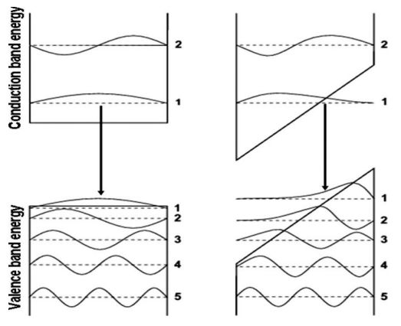

Figure 9: Spatial separation of electron and hole wave functions in QCSE [27]Leakage

**III. Semiconductor Physics**

To construct model studied numerically, it is necessary to be able to quantitatively describe the carrier distribution and the carrier dynamics in semiconductors.

**1 Dispersion relation and density of states (DOS)**

Semiconductors are solid-state materials with a periodic crystal structure. This means that atoms forming the semiconductor crystal are bound to well-defined lattice sites which repeat periodically and hence form a periodic crystal lattice.

The properties of electrons on the outermost atomic orbitals are strongly affected by the periodic potential created by the lattice: the electronic states become free-electron like and their energies form a quasi-continuum with bands of allowed and bands of disallowed energy values. Electronic states in semiconductors are essentially derived from the time-independent Schrödinger’s equation:

, (3)

where ψ(r) is the electron wave function, E is the electron energy and V(r) is the potential energy. The potential energy has the same periodicity as the crystal lattice so that V(r + a) = V(r), a being the lattice atom separation. It can be shown that in this case, the electron wave functions satisfy [28]

 (4)

where uk(r) has the same periodicity as the potential energy. This is the Bloch theorem for particles in a periodic potential. It can be seen that the wave function is the same as for free electrons apart from the periodic part uk(r), where k is the electron wave vector. The Bloch theorem can be used to show that in a periodic potential the allowed electron energies E(k) form a quasi-continuum with allowed and disallowed bands.

A nice and analytic example can be constructed by using e.g.  
the Kronig-Penney model in which the potential profile is composed of periodically repeating potential wells [29]. When calculating band-structures, one constructs the dispersion relation E(k) for all the allowed bands.

Dispersion relation can be solved with various methods  
that model the interaction of electrons with the crystal lattice, e.g. the tight binding  
method, the orthogonalized plane wave method and the pseudo potential method [28].

The dispersion relation of GaN is shown in Fig. 1, calculated with the pseudo potential method neglecting spin-orbit interaction. The highest completely occupied band is commonly known as the valence band and the lowest empty or only partially occupied band is known as the conduction band.

Usually we are interested only in the wave vector region near the band edges, i.e. near the band energy minima and maxima since the optical inter-band transitions

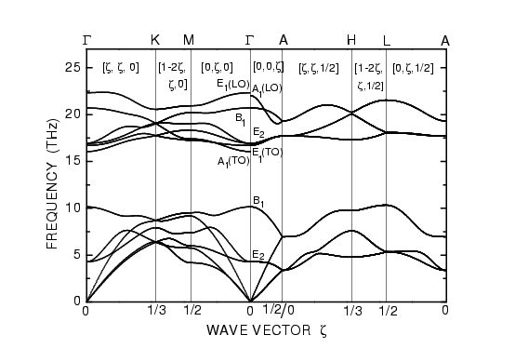

Figure 10: Dispersion relation of GaN calculated with the pseudo potential method neglecting spin-orbit interaction. GaN is a direct-gap semiconductor which means that the valence band maximum and the conduction band minimum occur at the same point in k-space.

Band gap between the conduction and valence bands is 3.39  
eV at Γ point which stands for k = 0. The figure is reproduced from Ref. [30].  
and current transport take place there. Band-structure near the band edges may  
be calculated with the k · p method or in the simplest approximation, as a simple  
parabolic relation with help of the concept of effective mass.  
In this thesis, the parabolic band approximation is used for approximating the  
dispersion relation. In the parabolic approximation, the dispersion relation is

, (5)

where Ec is the conduction band minimum, Ev is the valence band maximum and mc,v,ii are the effective masses for electrons in the conduction band and the valence band in the three orthogonal k directions, respectively. Effective masses are generally defined as a 3x3 tensor:

(6)

Note that for states close to maxima of the dispersion relation, the effective mass becomes negative. In these regions it is often useful to introduce the concept of a hole, i.e. a quasi-particle that corresponds to an empty electronic state. The holes in 5 the valence band behave just as the valence band electrons, except that the charge and the effective mass of holes are positive. The density of states (DOS) describes the number of available electronic states for a particular energy value, i.e. g(E) = dn/dE, where dn is the number of states in the interval dE (per unit volume). By using the parabolic dispersion relation, the conduction and valence band densities of states for 3-dimensional bulk material may be approximated as gc(E) = 1

 (7)

for the conduction band and

 (8)

for the valence band. Here the effective mass tensors are replaced by scalar values.  
The double degenerate valence band (heavy and light holes) is also represented by a single effective mass. Quantum wells (QWs) are material layers where one of the dimensions is on the order of the de Broglie wavelength for electrons. In QWs, the electronic states are quantized in the direction perpendicular to the QW layer. The density of states is calculated by first solving the discrete values for the perpendicular wave vector component k⊥ and the corresponding energy values from Schrödinger’s equation. After that, the density of states is solved separately for each discrete k⊥ value. By using the parabolic approximation it can be shown that the density of states is constant for each sub-band assigned by the values of k⊥. The conduction band densities of states for 3D bulk material and a 2D quantum well are compared in Fig.11

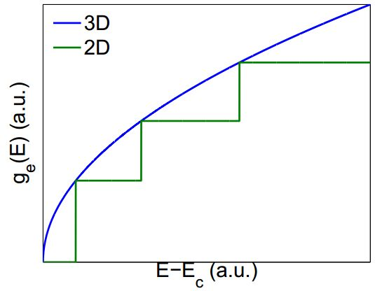  
Figure 11: Conduction band density of states for a 3D bulk material and a 2D  
quantum well.

**2.2 Carrier distribution**

In thermal equilibrium the occupation probability of an electronic state with energy E is given by the Fermi distribution:

, (9)

where EF is the Fermi level for electrons. The density of states for holes is the common valence band density of states written in Eq. (6) but the distribution  
function is the complement of the Fermi distribution, i.e. 1 − f(E) [30]. The carrier  
density in an energy band can be calculated from the DOS and the occupation  
probability as

. (10)

In intrinsic semiconductors, the Fermi level is located in the forbidden energy gap (commonly known as the band gap) between the conduction and valence bands. As a consequence, the occupation probability is f(E) = 1 for valence band states and f(E) = 0 for conduction band states at T = 0 K.  
As can be seen from Eq. (8), electrons start to excite from the valence band to the  
conduction band at positive temperatures. As a consequence, the conduction band  
becomes partially filled, the valence band is no longer completely filled and both  
bands start to conduct. The forming and calculation of conduction band electron  
density and valence band hole density are depicted in Fig. 11.

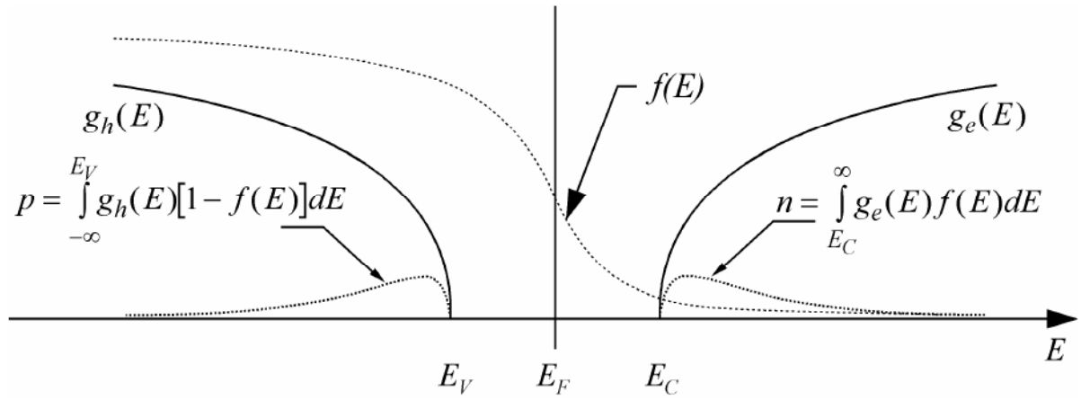

Figure 12: Fermi distribution, densities of states and electron and hole densities in an intrinsic semiconductor. The figure is reproduced from Ref. [31].  
In thermal equilibrium the Fermi level is common to both the conduction and  
the valence band. Under excitation of light or electric current, the Fermi level is  
divided into quasi-Fermi levels for the conduction band electrons and the valence  
band holes. Solving the values for the quasi-Fermi levels is part of the semiconductor current model presented. Numerical implementation of semiconductor carrier statistics is straightforward if one makes use of the Fermi-Dirac integral of the order 1/2, defined as,

(11)

where Γ is the Gamma function. Eq. (11) may be implemented as a numerical table, knowing that  [32]. With the parabolic density of states, Eq. (10) for conduction band electrons and a similar equation for valence band holes may be recast in the form

(12)

, (13)

where EFn and EFp are the quasi-Fermi levels for electrons and holes and Nc and Nv are the effective conduction and valence band densities of states, defined as   
and . (14)

**2.2.1 Boltzmann approximation**

Boltzmann approximation is an asymptotic approximation for Fermi-Dirac statistics that is used in many simplifying analytic models. In the approximation,  
the Fermi distribution is replaced by the Boltzmann distribution, resulting in

(15)  
 (16)

To illustrate the applicability of the Boltzmann approximation, the Fermi integral  
of the order 1/2 and the Boltzmann exponential are plotted in Fig. 4. It is seen  
that the Boltzmann approximation is good for Ec − EFn >> kBT or EFp − Ev >>  
kBT, i.e. when the quasi-Fermi levels are deep within the band gap. Boltzmann  
approximation can also be used for doped semiconductors (see the next section) as  
long as the doping densities are smaller than the effective densities of states.

* + 1. **Doping of semiconductors**

One of the technologically essential properties of semiconductors is the ability to dope them with impurity atoms. This means replacing atoms in the crystal by impurity atoms that become easily ionized at finite temperatures. Donors are atoms that can release one electron to the conduction band and acceptors are atoms that can bind one electron from the valence band. As a result, extra carriers are created in the semiconductor material.

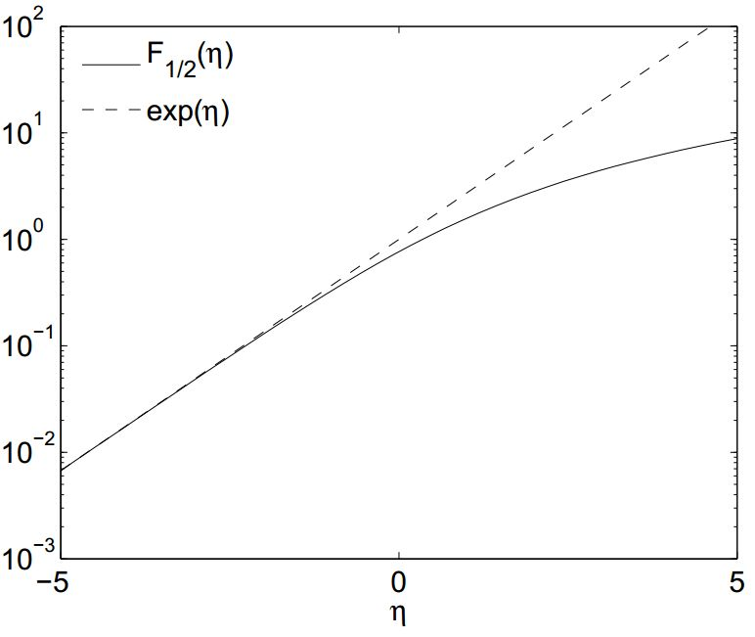

Figure 13: Fermi integral of the order 1/2 and its exponential approximation as a function of η = (EFn − Ec)/kBT or η = (Ev − EFp)/kBT. The approximation F1/2(η) = eη holds if η<< 0

The donors release additional electrons into the conduction band, so that the density of ionized acceptors is given by, (17) where nadd is the density of additional conduction band electrons. The density of nonionized donors in the Boltzmann approximation is given by, (18) where Nd is the total donor density, Nd0 is the density of non-ionized donors, gd is the donor state degeneracy and Ed is the donor state energy. The density of additional electrons is assumed to be much greater than the electron density of an intrinsic semiconductor so that nadd ≈ n. With this approximation we can use Eq. (15) for the additional electron density. By expanding the right-hand side of Eq. (18) with n we get

. (19)  
Rearranging terms gives the electron density in a semiconductor doped with donor  
atoms:

. (20)  
Eq. (20) shows that practically all the donors have released an electron into the conduction band if the ionization energy Ec − Ed is small and the density of donor atoms is significantly smaller than the effective density of states for the conduction band.  
A corresponding equation may be derived for the hole density in a semiconductor doped with acceptors:

, (21)  
where Na is the acceptor density, ga is the acceptor state degeneracy and Ea is the acceptor state energy. Again the hole density is the same as the acceptor density if  
the ionization energy is small and the acceptor density is significantly smaller than  
the valence band effective density of states. Formulas (20)-(21) hold when the Fermi level is well below (above) the donor (acceptor) energy state. This range can be expanded using the Fermi distribution in Eq. (16). The results are slightly more complicated than the ones in Eqs. (20), (21) but they hold also outside the application range for the Boltzmann approximation, i.e. when EF is close to Ed or Ea.  
**2.3 Current transport in semiconductors**

In this proposal, semiconductor current is modeled by a macroscopic model based on the drift-diffusion equations for current transport, the Poisson equation for electrostatic potential and the continuity equations for electrons and holes derived rom the Maxwell’s laws. In the model the electrostatic potential is solved from Poisson’s equation:

(22)

where D is the electric displacement field,  is the density of ionized donors and  is the density of ionized acceptors. Electric displacement field may be expressed by the electric field E~ and polarization P so that

, (23)

where φ is the electrostatic potential and ε0 is the permittivity of vacuum. In general, semiconductor materials have both built-in polarization fields and polarizations induced by the electric field. Polarizations induced by the electric field may be taken into account with relative permittivity εr so that

, (24)  
where Pint includes only the built-in polarizations unaffected by the electric field.  
The equation for electrostatic potential is given by substituting Eq. (24) into Eq.(22). The built-in polarization fields are discussed in more detail in Section 4.4. It must also be taken into account that the band energies follow the electrostatic potential so that Ec = Ec0 − qφ and Ev = Ev0 − qφ, where Ec0 and Ev0 are the band edges for the chosen zero potential level. Current in semiconductors is transported both by electrons in the conduction band and holes in the valence band. The continuity equations for electron and hole currents can be derived from Ampere’s law:

, (25)  
where H is the magnetic field and J is the total electric current. By taking the divergence of Ampere’s law, we get

(26)  
By using Eq. (22) for the electric displacement field and assuming the number of ionized dopants to be constant in time, equation (26) can be expressed as  
(27)

where J has been divided into electron and hole currents Jn and Jp. The equation can be rewritten as

. (28)

In Eq. (26), the left-hand side contains only n-dependent terms and the right-hand side contains only p-dependent terms. The equation can be separated by defining a new variable that must depend both on n and p:

(29)  
(30)  
where R is defined as the total recombination-generation rate with positive values of R standing for a net recombination [33]. A parametrized model for R will be presented in Section 2.4. In this thesis only steady-state equations are studied with the time derivatives set to zero. The transport equations for electron and hole currents can be written separately by assuming Boltzmann approximation to hold. The currents depend on the electric field (drift current) and carrier density gradients (diffusion current) so that

, (31)  
, (32)

where µn,p are the mobilities and Dn,p are the diffusion constants for electrons and holes, respectively. The diffusion constants are defined by the Einstein relation so that [34]. The current equations may be simplified with help of the Boltzmann approximation and the quasi-Fermi levels. By substituting Eqs. (15) and (16) in equation (29) and (30), the current densities may be expressed as

,(33)  
. (34)

Here we have defined new scalar fields, namely the quasi-Fermi potential fields, so that −q∇φn,p = ∇EFn,p. Eqs. (33), (34) are more favorable to solve numerically than Eqs. (29), (30) because of a better numerical stability achieved [31]. Eqs. (33), (34) are substituted in Eqs. (29), (30) to get the final equations for quasi Fermi potentials. The final equation system for solving steady-state values for φ, φn and φp is given by

(35)

All the boundary conditions for equation (35) may be formulated by using Dirichlet and Neumann boundary conditions. The boundary conditions for electrical contacts are Dirichlet-type, so that the boundary values of the electrostatic potential are given by the internal potential of the structure and the applied voltage. The internal potential is determined by the material compositions and doping densities of the structure as explained in Section 3.2. The boundary values of the quasi-Fermi potentials at the contacts are the same as the applied voltage values. At semiconductor-insulator interfaces it is usually required that the electric flux and electric current outside the semiconductor vanish. This requirement results in the Neumann boundary conditions given by

, (36)

where n is the unit normal vector at the surface. Neumann boundary conditions are also applied at the interfaces between two different semiconductor regions so that

(37)

where the subindices 1 and 2 refer to the two regions alongside the interface.  
**2.4 Recombination in semiconductors**

Recombination is an inter-band relaxation process in which an electron is transferred from the conduction band to an empty state in the valence band (i.e. the electron recombines with a hole). Energy is released in the recombination process as light or as heat. The operation of LEDs is based on radiative recombination in which the energy is released in the form of light. In addition to the radiative recombination, the most notable recombination processes include the non-radiative Shockley-Read-Hall and Auger recombination in which the energy is eventually released as heat. The theoretical models of recombination are essentially based on the time-dependent quantum-mechanical models and the time-dependent perturbation theory. These theories can be used to derive Fermi’s golden rule which can, in principle, be used to calculate the rates of the different recombination processes. The underlying theory and methods, however, are very complex and out of the scope of this thesis. Nevertheless, the different recombination mechanisms can be reliably and easily modeled with the following well known and widely used parametrized models. The rate of radiative recombination in the parametrized model is given by

  
where B is the radiative recombination coefficient and is the intrinsic carrier concentration [33]. Eq. indicates that there is no radiative recombination in thermal equilibrium with zero current. The equation may be expressed with help of the quasi-Fermi potentials by applying Boltzmann statistics, so that  


The numerical value for B has been calculated for group III nitrides by application of interband transition matrix element decomposition by Dmitriev and Oruzheinikov [35]. The calculated values were on the order of 10−16 m3/s for all material compositions. In Shockley-Read-Hall (SRH) recombination, the carriers recombine via traps in the band gap caused by defects and impurities. The relaxation energy is released as phonons, i.e. lattice vibrations. SRH recombination is parametrized by electron and hole lifetimes so that

  
where and are the SRH lifetimes of electrons and holes which depend on trap densities and trap capture cross-sections [36]. andare the equilibrium values for electron and hole densities, respectively. It is commonly assumed that  and the SRH recombination coefficient is defined as.  
A significant number of band gap states usually occur near passivated semiconductor surfaces. At surfaces the crystal periodicity is broken and valence orbitals form into electronic states located inside the band gap. For this reason, the semiconductor surface areas act as powerful non-radiative recombination centers and LED active regions should be located so that they are far from surfaces. Theoretical prediction of the surface states is very difficult and instead, simplifying macroscopic models are commonly used with surface emission velocities solved by fitting the models to experimental data, as in Ref. [37]. In group III nitrides, a significant number of threading dislocations is additionally created as a result of the imperfect crystal growth on a sapphire substrate. Auger processes are generation and recombination processes in which the electron hole pair interacts with a third carrier.

|  |
| --- |
|  |
| Fig.14 Radiative, non-radiative recombination and current leakage in QW [38] |

In Auger recombination processes, the relaxation energy is initially given to a third carrier which quickly releases the energy to lattice phonons, so that no photons are created in the process. In Auger generation processes, an electron-hole pair is created due to collision with an energetic third carrier. The net Auger recombination rate taking into account all the recombination and generation processes is given by

  
where Cn and Cp are the Auger recombination coefficients [33]. Usually the Auger recombination coefficients are assumed equal so that the common Auger coefficient is defined as C =Cn =Cp. The total recombination rate is calculated by summing together all the three recombination processes. In this thesis the coefficients for electrons and holes are assumed to be equal so that the total recombination rate is given by

  
Recombination parameter values for nitride compositions have been measured by photoluminescence experiments e.g. by Shen et al. [38]. They measured the coefficients at high current density levels and as a result, the estimates for A, B and C were on the order of 107 s−1, 10−17 m3s−1 and 10−42 m6s−1.

# IV. METHOD

In our model, the high aspect ratio of device, and the high aspect geometries present their own array of modeling challenges.

## (Electronic) 3D Poisson and Drift-Diffusion Model

In this section, we will concentration on the procedure of how to combine 3D FEM Poisson and drift-diffusion solver and 3D FEM thermal solver. Given the entire model used for the LED current ﬂow has strong directional properties. However, the mesh size spacing needed to exactly describe current ﬂow in the active region made from hetero-junctions and/or the quantum well is very small. Therefore, a full 3D modeling will need many memories. Using the geometry of current ﬂow we have developed a 3D approach which we believe provides a good approximation for current ﬂow. For the heat dissipation one has to use a full 3D approach but since the thermal diffusion length is large the mesh spacing can be large and the problem is easy to handle from a memory point of view. Finite element method (FEM) is used for both the current ﬂow and heat dissipation. Since the current has directional properties, we can analyze the current spreading in cross section of the device with 3D FEM method. Then the current spreading and energy loss proﬁle of each element can be applied into the 3D FEM thermal modeling model.



*Fig.15.*A schematic ﬂow chart of the process for simulating the electrical, thermal and optical model

Electronic

Thermal

Optical

**Build 3D model**

**Mesh the 3D model to solve the equations**

**Use FEM to solve the 3D Poisson and drift-diffusion equations**

**Receive non-radiative and radiative recombination rates, electron and hole concentration, electron and hole current distribution**

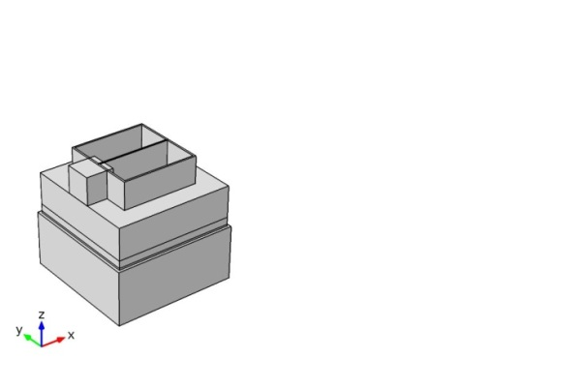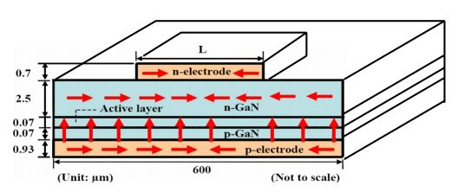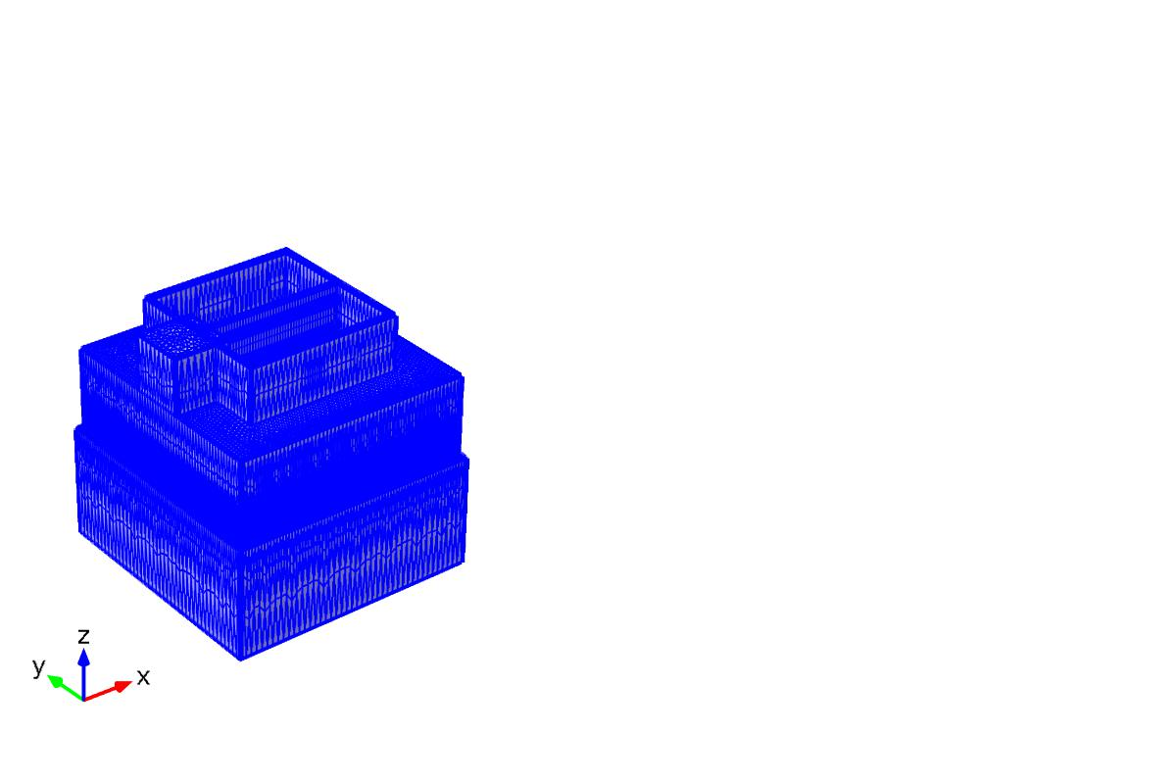

## (1) Built a 3D model we want to simulate. At ﬁrst, we will build a 3D model and set the boundary conditions for each outer surface. Set the doping layer in the entire model, ohmic contact, insulator conditions.

## (2) Mesh the model to solve the system equation. We use the free triangular to mesh the surface, after that swept the layers under the surface with the same area. If the surface below the first surface is difference we must use another free triangular to mesh and swept again. The size of the element is not difference too much in each axis.

## (3) Solve the 3D Poisson and drift-diffusion equations with ﬁnite element method. For the 3D FEM Poisson and drift-diffusion solver, we solve the following equations self-consistently to obtain the electrostatic- potential and current distribution of hole and electron.







(46)

where V is the band potential of the device. Where Jn and Jp are the electron and hole current. R is carrier recombination term including radiative and non-radiative recombination. The equation (43) is the Poisson equation, the right hand side is the charge density with the doping profile. N and P is the hole and electron concentration. The term  is the doping profile in this equation. On the left hand side is the electrostatic potential. .The equations are the drift-diffusion equations for electron current and hole, and the equation of continuity. With two parts importance in these equation is the diffusion of electron and hole when no outside electric potential applied to system and the other part is the drift showing the affection of the electric potential outside to forcing the electron and hole moving with the electric direction from positive to negative. The equations are solved iteratively until a converged result is obtained. (4) Receive non-radiative and radiative recombination rates, electron and hole concentration, electron and hole current distribution. We use the Shockley – Read – Hall model to calculate for the non-radiative recombination and the direct recombination with B is the radiative recombination coefficient. The B coefficient value is not be constant but in this proposal just consider this is the constant. After that, we can use this recombination to calculate the heat source and internal quantum well (IQE).

## Thermal Field Theory

### 2.1 Governing Equation and Boundary Condition

The heat in LEDs is mainly transferred by conduction. Based on the energy conservation, the internal energy change rate is equal to the net energy transferred by conduction and internal heat source. Similar derivation in section 2.5.1 is available to the thermal field. The energy conservation is



k the thermal conductivity,  the internal heat source.

Internal heat source in LEDs can be divided into two mechanisms：

Series resistance: Joule's law indicates that when the current passes through a conductor, part of electric energy is consumed by resistance, and converted it to the heat. In LEDs, series resistance is constituted by the contact resistance and the resistance of the neutral regions. After current passes through the series resistance, Joule heating is generated and then becomes the internal heat source.



where  is Joule heating;  represents the electric field.

Nonradiative recombination: based on the principle of SRH recombination, an electron from conduction band is captured by defect level at the central of band gap, and then emitted to valence band. The phonon is emitted in both capture and emission processes. Therefore, the released energy by SRH recombination is equal to the semiconductor band gap. For the case of Auger recombination, carrier is excited to higher level by absorbing the photon, and gives off its energy thermally. Finally it will back to the band-edge by relaxing. The total energy releasing is also equal to the semiconductor band gap. To sum up, internal heat source is



The heat is generated in active layer, the energy passes through the chip, die attach (DA), aluminum alloy, solder, to MCPCB, and finally transfers to the ambient by convection.

1. **Optical Field Theory**

### 3.1 Snell’s Law

While the light enters the medium from the other medium, its moving direction will change.

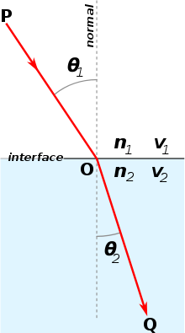

*Fig.16*. [Refraction](http://en.wikipedia.org/wiki/Refraction) of light at the interface between two media of different refractive, with n2 > n1. Since the velocity is lower in the second medium (v2 < v1), the angle of refraction θ2 is less than the angle of incidence θ1; that is, the ray in the higher-index medium is closer to the normal.

Snell’s law has described the relationship between the incident and refraction angle. It can be expressed by the following formula

|  |  |
| --- | --- |
|  |  |

where n1 is the refractive index of material from the incident ray; is the angle between the incident ray and the normal of the boundary; n2 is the refractive index of material from the refractive ray; is the angle between the refractive ray and the normal of the boundary.

**3.2** **Total Internal Reflection**

When the ray travels from a medium with large refractive index to a small refractive index medium with small refractive index, part of the ray penetrates the interface, other reflects.

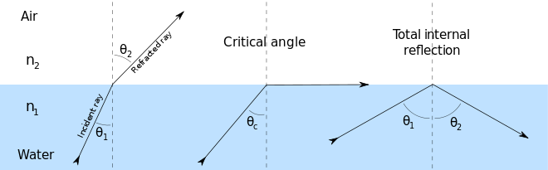

*Fig.*17. Refraction of light at the interface between two media, including total internal reflection.

As the refractive angle is greater than  degree, the incidence ray will be totally reflected to original medium. This angle is called critical angle for total internal reflection (, From Eq. (53), we can derive the critical angle:

|  |  |
| --- | --- |
|  |  |
|  |  |

### 3.3 Beer-Lambert-Bouguer Law

When the ray transmits an absorbing medium, part of ray will be absorbed, others will penetrate. Moreover, the degree of penetration and absorption are related to the thickness and the semiconductor band gap. The relationship between thickness and absorbance can be explained by Beer-Lambert law [69]:

|  |  |
| --- | --- |
|  |  |

From Eq. (2.78), we can derive to another formula by Bouguer law:

|  |  |
| --- | --- |
|  |  |

Where OD is absorbance, the value is between zero to infinity; Ttran is transmittance. I1 is the incident ray power, I2 the power after penetrates the medium, K peak the maximum extinction coefficient, l the medium thickness, Color the molar concentration,  the absorption coefficient.

In semiconductors, if the photon energy is larger than or equal to the band gap of the semiconductor, then the probability of absorption of a photon will increase. If the photon energy is below the semiconductor band gap, free-carrier absorption becomes the dominant absorption mechanism, as shown in Fig. 2.18. As the name suggests, a free carrier is excited to a higher energy by absorption of a photon, then it relaxes to the ground state thermally. Since the active layer absorbing is much more significant, the free-carrier absorption is negligibly small. The absorption coefficient of direct band gap semiconductor is proportional to the square root of difference of incident photon energy and material band gap [40]:

|  |  |
| --- | --- |
|  |  |

where Eph is the incident photon energy.

### 3.4 Fresnel Loss

When the light transmits in the different medium, two different refractive index causes part of light reflects back to original medium which is called Fresnel reflection loss [41].

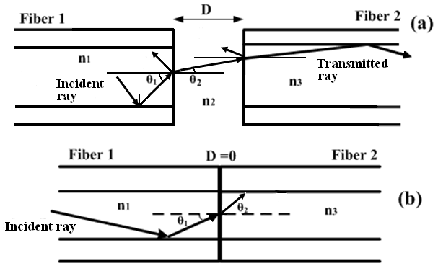

*Fig.*18. [Analysis of Fresnel Loss at Splice Joint](http://article.sapub.org/10.5923.j.optics.20120201.02.html)

Ignoring the polarization and absorption of the light, the transmissivity and the reflectivity can be expressed as below

|  |  |
| --- | --- |
|  |  |

where  is reflectivity, and are the refractive index from two different medium. From the above equation, when the greater difference of refractive index between two mediums, the Fresnel loss comes larger.

**III EQUIPMENT FOR MEASUREMENT PURPOSE**

All the results and improvements have been made possible thanks to the analysis of measurement data. We set up some system to measure the thermal and the optical characteristic of LEDs devices .The following list is not exhaustive, but gives an overview of the most important ones.

## Junction Temperature Measuring Theory

The temperature effect has the significant impact on the optical and electrical properties of LED. Therefore the junction temperature measurement is important to LED researches. There are various measuring methods, among them, forward-biased has been widely used which is proposed by F. Schubert [42]. Measurement specification is based on the EIA/JEDEC51-2 [43] for IC semiconductor elements detection. The forward-biased method is derived by Shockley equation, which describes the relation between the temperature and the forward bias. Under the same current injection, the corresponding forward bias shows the linear function with decreasing temperature. The junction temperature can be obtained through the voltage difference affected by the temperature.

The measuring starts from the initial current (IM), and the corresponding voltage is  which is obtained by the I-V curve. The value of IM is small for avoiding the self-heating effect, as shown in Fig. 19. Next we put the sample into the temperature-controlled oven, as shown in Fig. 20,

|  |
| --- |
|  |
| Fig. 19 I-V curve of *TFC* and *NLC* |
| C:\Users\lhpg\Desktop\新增資料夾 (2)\Fig.3.2.jpg |
| Fig. 20 LED in the temperature-controlled oven |

and utilize the IM to drive the device. Here, we take down the forward bias just under the surrounding temperature in the same intervals. The forward bias influenced by the temperature is called temperature sensitive parameter (TSP). Plotting the TSP versus the surrounding temperature, and the linear relation can be found. Fitting the result with linear regression, the slope is K factor. In the final part, we put the LED into sample test room under the thermal equilibrium condition (T0)­.

First input the IM­, and then apply the working current (IH) until the steady state reaches, and records the corresponding forward bias (). After the change of the TSP is obtained, the junction temperature is

|  |  |
| --- | --- |
|  | (58) |

## Junction Temperature Measuring System

The measuring system includes the DC power meter (Keithley 2400), the temperature-controlled oven (Poworld, BC-2), the sample test room, the thermocouple (T type), and the temperature sensor (SE045E006). The PC and the sensor are connected by the RS232, and the accuracy is 0.1. The whole measuring system is shown in Fig. 22. The system can be divided into two main steps. At the first step, K factor is measured, and the instrument process is shown in the blue arrow of Fig. 22. Then the second step is to evaluate the junction temperature as shown in the process of red arrow.

### K Factor Calibration Curve

The junction temperature is very sensitive to the K factor. As the result, before the measurement, the temperature-controlled oven must warm-up at least 20 minutes. The damage of the LED samples should be avoided, for insuring the stable I-V behavior.

The turn-on current IM is given 5mA for two different samples to prevent the self-heating which will cause the measurement errors. The surrounding temperature is adjusted from 40℃ to 90℃, and every 10℃ takes down the corresponding forward bias in thermal equilibrium. The K factor can be derived from the slope of the TSP.

|  |
| --- |
| C:\Users\lhpg\Desktop\新增資料夾 (2)\Fig.3.3.jpg |
| Fig. 21 LED in the sample test room |

|  |
| --- |
|  |
|  |
|  |
| Fig. 21 Junction temperature measuring system |

### Junction Temperature

In the experiment, the thermocouple is used to measure the temperature on the MCPCB, thus the calibration is important. The method is that the measuring thermocouple will calibrate by a temperature calibrator (Fluke-9103) which accuracy is ±0.02℃, and the calibration function can be evaluated by the linear regression analysis, as shown in Fig. 22. The LED sample is under the nature convection condition, afterward, thermocouple is attached on the bottom of the MCPCB and puts into the sample test room to avoid the convective disturbances.

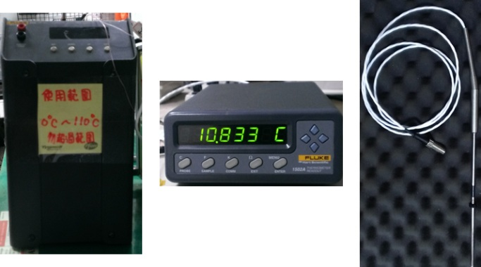

Fig. 22 Temperature calibrator



Fig. 23 Calibration curves of different thermocouple

## Optics Measuring System

The light output power and *EQE* can be measured by integrating sphere (Sphere Optics 12”), Fig. 24 shows the measuring system. For every measuring, the calibration under the standard light source inside the integrating sphere is needed. Then the LED device is driven by the constant current (Aglient E3634A) with the same process in junction temperature measurement.

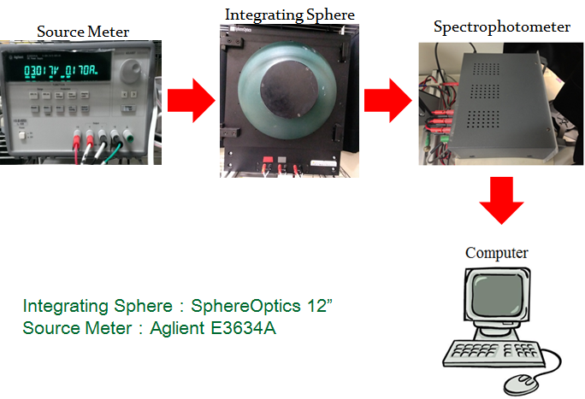

Fig. 24 Optics measurement system

**IV Progress in implementation**

1. **The first year (August 1 104 years to 105 years July 31)**

**1.1 Parts of numerical simulation:**

1. Construction three-dimensional numerical simulation model of electrical vertical – LEDs based on semiconductor equation system. Figure out the reasonable value of parameter to serve for the numerical model.
2. Applying this method to some various available chip as Cree, Epistar, Nichia LEDs chip.
3. Validating this model with previous model based on the resistivity method.
4. Validating with the experiment and some conclusions about the semiconductor method.

**1.2 Experimental parts:**

We measure the electrical characteristic of various chips to validate with the numerical model. Use some equipment as: source to apply the voltage or current into the chip, measurement equipment as source meter to measure the voltage and current, software to observe the value of voltage and current so we can receive the I-V curve, microscope to observe the light output power distribution at difference power.

1. **The second year (August 1 102 years to 103 years July 31)**

**2.1 Parts of numerical simulation:**

The definition of LEDs efficiency as Internal Quantum Efficiency (IQE), External Quantum Efficiency (EQE), Wall Plugin Efficiency (WPE) will be calculated from the numerical model.

The coupling of the thermal effect with the three-dimensional numerical simulation model of electrical vertical will be carried out.

The validation of a three-dimensional thermoelectric LED coupling chip numerical model for the simulation.

**2.2 Experimental parts:**

We investigate a method to measure the thermal of LED chips. We measure the thermal characteristic of various chips to validate with the numerical model after coupling the thermoelectric. Use some equipment as: oscilloscope, power supply, computer, temperature sensor, temperature-controlled oven, sample test-room

**3. Third year (August 1 year 106 to 107 years July 31)**

**3.1 Numerical simulation of parts:**

The results of thermoelectric coupling provide as a source of optical simulation.

The three- dimensional numerical model with electrical, thermal and optical will completely construct.

The mutual influence of the parameter properties between electrical, thermal and optical will be investigated by the full model.

After validating with the experiment, we can optimize the high efficiency LEDs chips.

**3.2 Experimental part:**

LEDs optically coupled to a thermoelectric three-dimensional numerical simulation of the photovoltaic (such as surface temperature, Luminous flux, luminous intensity) will be conducted to measure results for comparison.

A new LabVIEW© program will be developed for EL measurement station. The motivation was to automate the entire station in order to drastically decrease measurement time and to obtain more accurate results thanks to a better repeatability.

**V. The expected results of the project**

**1. The first year (August 1 104 years to 105 years July 31)**

1. The setting up the method from the semiconductor fundamentals will handle first.
2. We construct the 3D numerical model based on the semiconductor fundamentals.
3. Establishing the finite element method solves the highly nonlinear Poisson and Drift-Diffusion equations.
4. This numerical model will used to validate with the experimental results.
5. Construction some available commercial chips to check the hypothesis.
6. To validate the I-V curve and IQE between the experiment and numerical solution.
7. Investigating the effect of the current blocking layer, doping on the p-GaN, thickness of active layer and the others layer to the current distribution will be figured out.
8. The effect of the parameter properties as mobility, density of state, direct recombination coefficient, lifetime carrier, Auger coefficient on the IQE and the I-V curve will be discussed.
9. **The second year (August 1 105 years to 106 years July 31)**
10. The effects of thermal will be added into the 3D model.
11. The effects of thermal on the carrier concentration, mobility, band-gap energy level, radiative recombination rate, non-radiative recombination rate, I-V curve, current distribution, IQE, LEE, WPE will be investigated.
12. The thickness and doping of active layer, the n-GaN and p-GaN affect on the electron concentration, I-V curve, IQE, LEE, WPE.
13. The three-dimensional of the thermoelectric simulation results will be analyzed to increase the efficiency and decrease droop effect.
14. **The third year (August 1 106 years to 107 years July 31)**
15. The optical characteristic will be simulated by another software as Tracepro software.
16. The effects of absorption of active layer and the package on the efficiency of LEDs chip.
17. The thickness and doping of active layer, the n-GaN and p-GaN effect on the electron concentration, I-V curve, IQE, LEE, WPE.
18. The three-dimensional of the thermoelectric and optical simulation results will be designed to increase the efficiency and reduce droop effect.

**Reference**

[1] W. B. Joyce and S. H. Wemple , “Steady State Junction Current Distributions in Thin Resistive Films on Semiconductor Junctions (Solutions of 2v = ±ev)”

[2] Hyunsoo Kim, Seong-Ju Park, and Hyunsang Hwang) , “Lateral current transport path, a model for GaN-based light-emitting diodes: Applications to practical device designs”

[3] Joachim Piprek,i Tom Katona, Steven P. DenBaars, and Simon Li,”3D Simulation and Analysis of AlGaN/GaN Ultraviolet Light Emitting Diodes”  
[4] Hyunsoo Kim, Kyoung-Kook Kim, Kwang-Ki Choi, Hyungkun Kim, June-O Song et a, “Design of high-efficiency GaN-based light emitting diodes with vertical injection geometry “

[5]. Sungmin Hwang and Jongin Shim,”Steady A Method for Current Spreading Analysis and Electrode Pattern Design inLight-Emitting Diodes”

[6]Farn Shin Hwu, Jyh-Chen Chen, Sheng-Han Tu, Gwo-Jiun Sheu,Hsueh-I Chen, and Jinn-Kong Sheu,” A Numerical Study of Thermal and Electrical Effects in a Vertical LED Chi”

[7] Chi-Kang Li and Yuh-Renn Wu, “Study on the Current Spreading Effect and Light Extraction Enhancement of Vertical GaN/InGaN LEDs”

[8] I. V. Rozhansky, D. A. Zakheim, “Analysis of The Causes of The Decrease in The Electroluminescence Efficiency of AlGaInN Light Emitting Diode Heterostructures at High Pumping Density”, Semiconductors, vol. 40, no. 7, pp. 839-845, Jul. 2006.

[9] I. V. Rozhansky, D. A. Zakheim, “Analysis of Processes Limiting Quantum Efficiency of AlGaInN LEDs at High Pumping”, Phys. Status Solidi A, vol. 204, no. 1, pp. 227-230, Jan. 2007.

[10] I. A. Pope, P. M. Smowton, P. Blood, J. D. Thomson, M. J. Kappers, C. J. Humphreys, “Carrier Leakage in InGaN Quantum Well Light Emitting Diodes Emitting at 480 nm”, Appl. Phys. Lett., vol. 82, no. 17, pp. 2755-2757, Apr. 2003.

[11] M.-H. Kim, M. F. Schubert, Q. Dai, J. K. Kim, E. F. Schubert, J. Piprek, and Y. Park, “Origin of Efficiency Droop in GaN-Based Light-Emitting Diodes”, Appl. Phys. Lett., vol. 91, pp. 183507/1-3. Oct. 2007.

[12] M. F. Schubert, J. Xu, J. K. Kim, E. F. Schubert, M. H. Kim, S. Yoon, S. M. Lee, C. Sone, T. Sakong, Y. Park, “Polarization-Matched GaInN/AlGaInN Multi-Quantum-Well Light-Emitting Diodes With Reduced Efficiency Droop”, Appl. Phys. Lett., vol. 93, pp. 041102, Jul. 2008.

[13] Y. C. Shen, G. O. Mueller, S. Watanabe, N. F. Gardner, A. Munkholm, and M. R. Krames, “Auger Recombination in InGaN Measured by Photoluminescence”, Appl. Phys. Lett., vol. 91, pp. 141101, Oct. 2007.

[14] A. A. Efremov, N. I. Bochkareva, R. I. Gorbunov, D. A. Larinovich, Yu. T. Rebane, D. V. Tarkhin, and Yu. G. Shreter, “Effect of The Joule Heating on The Quantum Efficiency and Choice of Thermal Conditions for High Power Blue InGaN/GaN LEDs”, Semiconductors, vol. 40, no. 5, pp. 605-610, May 2006.

[15] S. F. Chichibu, A. Uedono, T. Onuma, S. Nakamura, S. Yamaguchi, S. Kamiyama, H. Amano, I. Akasaki, “Origin of Defect-Insensitive Emission Probability in InContaining (Al,In,Ga)N Alloy Semiconductors”, Nat. Mater., vol. 5, no. 10, pp. 810-816, Oct. 2006.

[16] S. F. Chichibu, T. Sota, K. Wada, and S. Nakamura; “Exciton Localization in InGaN Quantum Well Devices”, J. Vac. Sci. Technol. B, vol.16, no. 4, pp. 2204-2214, Aug. 1998.

[17] A. R. Vasconcellos, R. Luzzi, C. G. Rodrigues, and V. N. Freire; “Hot Phonon Bottleneck in The Photoinjected Plasma in GaN”, Appl. Phys. Lett., vol. 82, no. 15, pp. 2455-2457, Apr. 2003.

[18] J. H. Ryou, P. D. Yoder, J. Liu, Z. Lochner, S. Choi, H. J. Kim, R. D. Dupuis, “Control of Quantum Confined Stark Effect in InGaN-Based Quantum Wells”; IEEE Jour. of Sel. Topics in Quant. Elec., vol. 15, no. 4, Aug 2009.

[19] Cooke, “Solutions Don’t Solve Droop Controversy”, Semiconductor Today, Compounds and Advanced Silicon, vol. 3, issue 9, Nov 2008.

[20] Shen et al., Appl. Phys. Lett., vol. 91, 2007.

[21] Ni et al., Appl. Phys. Lett., vol. 93, 2008.[22] Y. C. Shen, G. O. Mueller, S. Watanabe, N. F. Gardner, A. Munkholm, and M. R. Krames, “Auger Recombination in InGaN Measured by Photoluminescence”, Appl. Phys.Lett., vol. 91, pp. 141101, Oct. 2007.

[23] U. Ozgur, H. Liu, X. Li, X. Ni, H. Morkoc, "GaN-Based Light Emitting Diode: Efficiency at High Injection Levels", Proceedings of the IEEE, 2009.

[24] E. Kioupakis, P. Rinke, K. T. Delaney, C. G. Van de Walle, “Indirect Auger Recombination as a Cause of Efficiency Droop in Nitride Light-Emitting Diode,” Appl. Phys. Lett., vol. 98, pp. 161107, 2011.

[25] E. Kioupakis, P. Rinke, A. Schleife, F. Bechstedt, and C. G. Van de Walle, Phys.Rev. B, vol. 81, pp. 241201, 2010.

[26] Ni et al., Appl. Phys. Lett., vol. 93, 2008.

[27] J. H. Ryou, P. D. Yoder, J. Liu, Z. Lochner, S. Choi, H. J. Kim, R. D. Dupuis, “Control of quantum Confined Stark Effect in InGaN-Based Quantum Wells”; IEEE Jour. of Sel. Topics in Quant. Elec., vol. 15, no. 4, Aug 2009.

[28] J. Singh. Physics of Semiconductors and Their Heterostructures. McGraw-Hill, Inc., 1993. ISBN 0-07-057607-6. [29] J. Sinkkonen. Puolijohdeteknologian perusteet. Helsinki University of Technology, 1996. ISBN 951-22-3242-1.

[30] NSM Archive - Physical Properties of Semiconductors. Cited 8th June 2010. Available at <http://www.ioffe.ru/SVA/NSM/Semicond/index.html>

[31] J. Tulkki. Fermijakauma puolijohteissa. Course handout, S-114.1327 Physics III. Helsinki University of Technology, 2007.

[32] O. Heikkil¨a. Numerical Modeling of High Efficiency LEDs. Master’s Thesis. Helsinki University of Technology, 2008.

[33] M. E. Levinshtein, S. L. Rmuyantsev and M. S. Shur. Properties of Advanced Semiconductor Materials. John Wiley & Sons, 2001. ISBN 0-471-35827-4.

[34] S. L. Chuang. Physics of Photonic Devices. John Wiley & Sons, 2009. ISBN 978-0-470-29319-5.

[35] P. Bhattacharya. Semiconductor Optoelectronic Devices. Prentice Hall, 1997. ISBN 0-13-495656-7.

[36] A. Dmitriev and A. Oruzheinikov. The rate of radiative recombination in the nitride semiconductors and alloys. Journal of Applied Physics, 86, 1999.

[37] W. Shockley and W. T. Read Jr. Statistics of the Recombinations of Holes and Electrons. Physical Review, 87, 1952.

[38] Joachim Piprek . Efficiency droop in nitride-based light-emitting diodes. Phys. Status Solidi A 207,10,2010

[39] R. Aleksiejunas et al. Determination of free carrier bipolar diffusion coefficient and surface recombination velocity of undoped GaN epilayers. Applied Physics Letters, 83, 2003.

[40] Y. C. Shen et al. Auger recombination in InGaN measured by photolumines cence. Applied Physics Letters, 91, 2007.

[41] K. Laqual, W. H. Melhuish, M. Zander, “Molecular Absorption Spectroscopy, Ultraviolet and Visible (UV/VIS),” Pure Appl. Chem., 60, 1449-1460, (1988).

[43] E. F. Schubert, “Light-Emitting Diodes”, 2nd ed., Cambridge University Press, Cambridge, England (2006).

[44] Y. Xi, E. F. Schubert, “Junction-temperature measurement in GaN ultraviolet light-emitting diodes using diode forward voltage method,” Appl. Phys. Lett., 85, 2163(2004).

[45] EIA/JEDEC Standard : “EIA/JEDEC51-2”, Electronic Industries Alliance, Engineering Department, Arlington (1995).